Playworks  Monthly  Newsletter | Our Partnership    

“Get to know Coach E.J.”  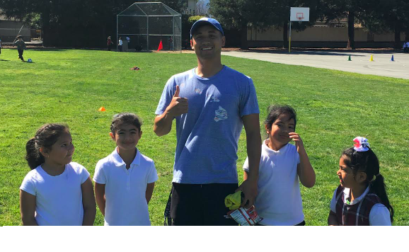  I have been a Coach for Playworks for 2 years. Some of my favorite games are 3-line basketball, flag tag, and ro sham bo dodgeball. I will be here 1 week out of the month and I look forward being here on those days. This upcoming school year I hope to impact the community in a positive way! | August Timeline  First day: August 22nd  Second Day: August 24th  (Goals: Get Junior Coach candidates, play during recess, and get Teachers to sign up for Class Game Time)  September Timeline  First Full Week: September 17th-21st  (Goal: Start Class Game Times!!!)

